#### FR01: Register account

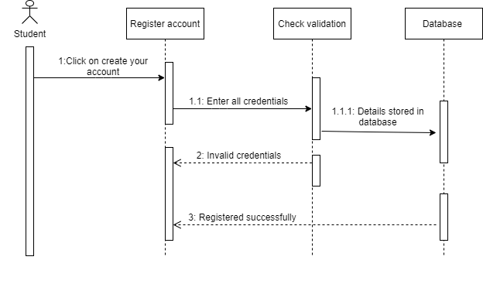

#### FR02: Login account

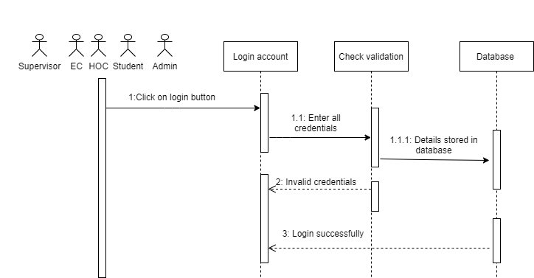

#### FR03: Update Profile

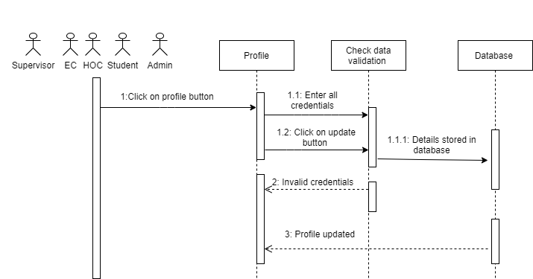

#### FR04: Add Project

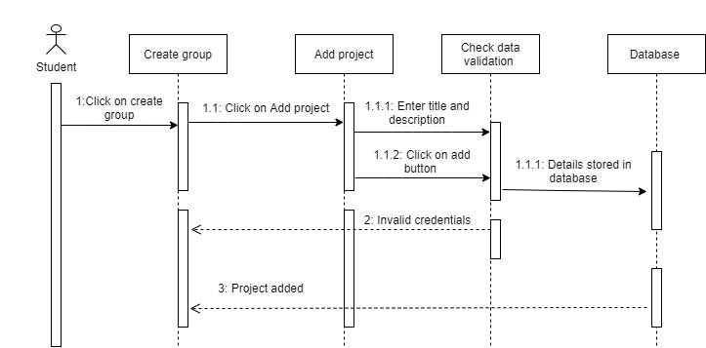

#### FR05: Add member

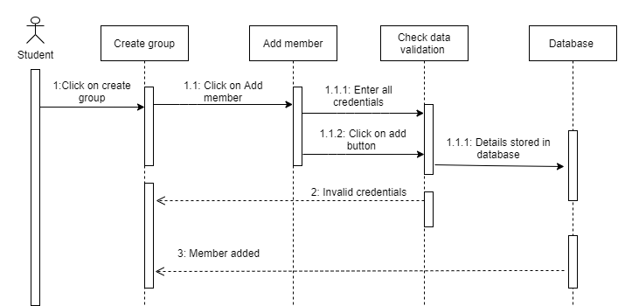

#### FR06: Select Supervisor

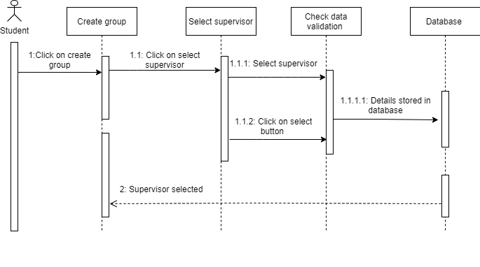

#### FR07: Submit Proposal

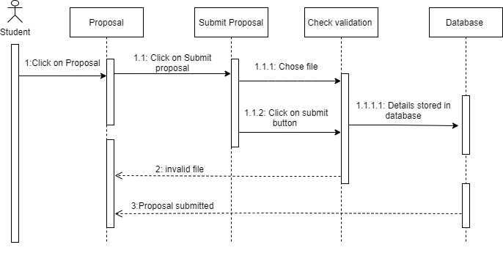

#### FR08: Chat Box

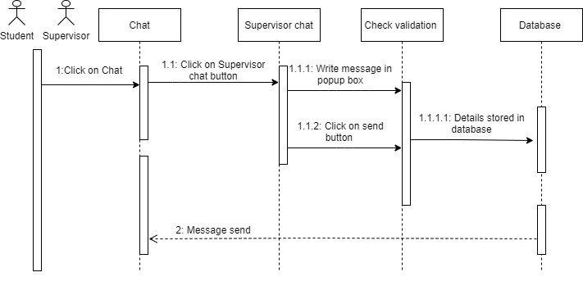

#### FR09: Phase 1 Submission

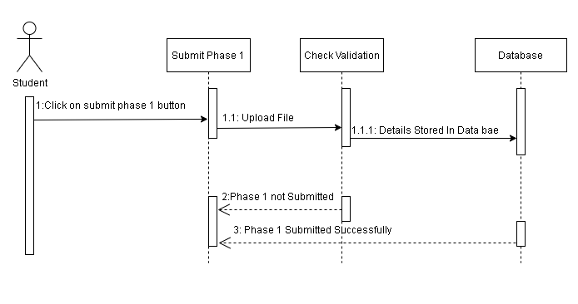

**FR10: Phase 2 Submission**

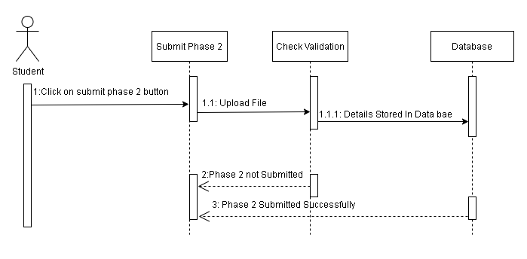

#### FR11: Create Student Account

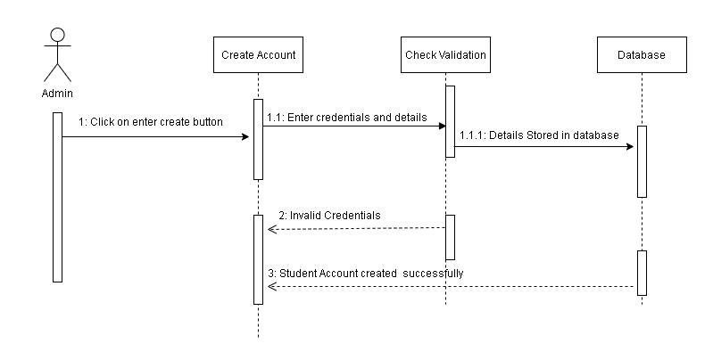

**FR12: Create Supervisor Account**

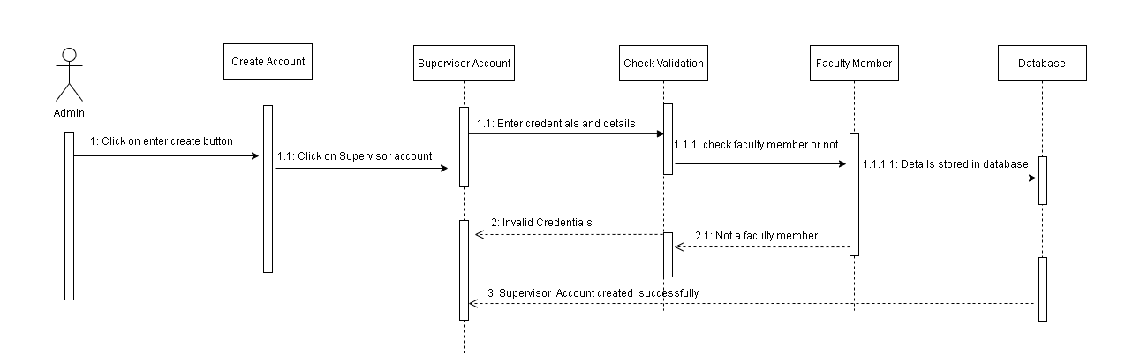**FR13: Create Evaluation Committee Account**

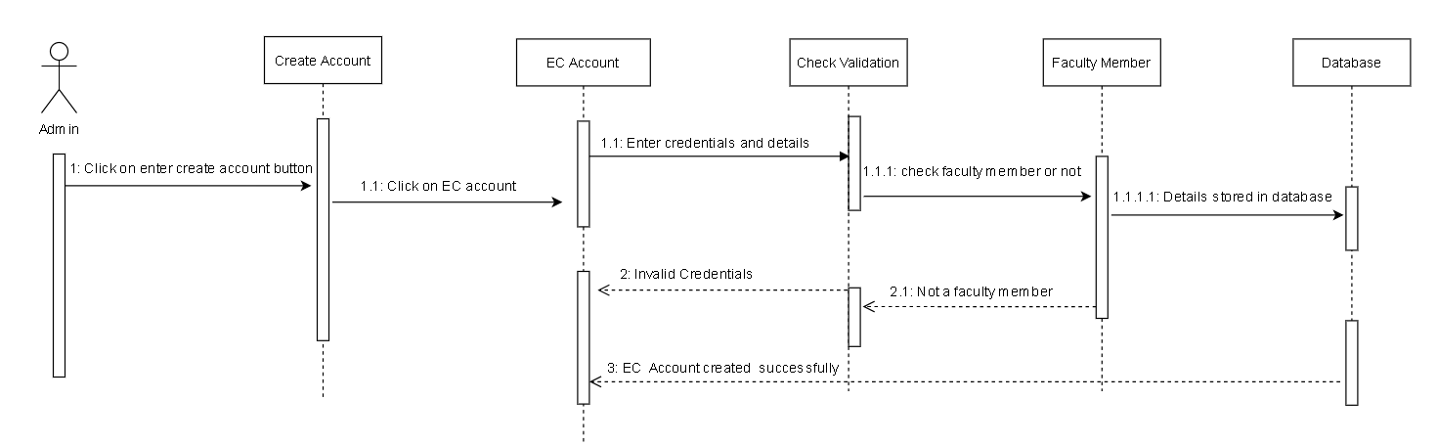

**FR14: Project Assign Limitation**

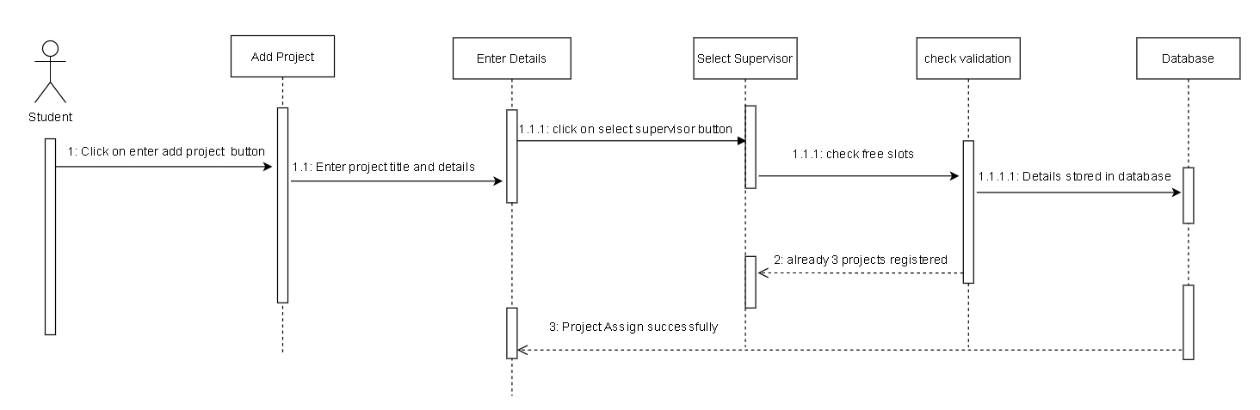

**FR15: Create Head of Committee Account**

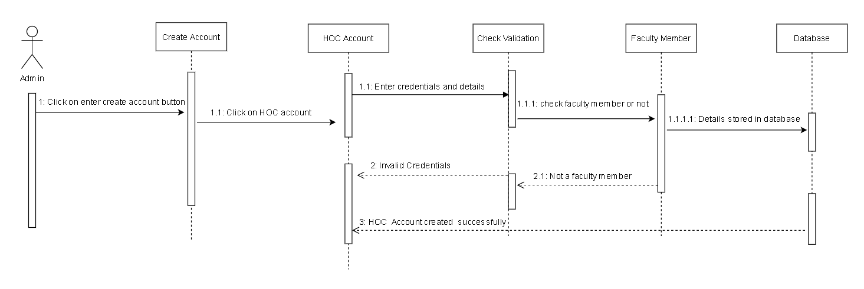

#### FR16: Add faculty details

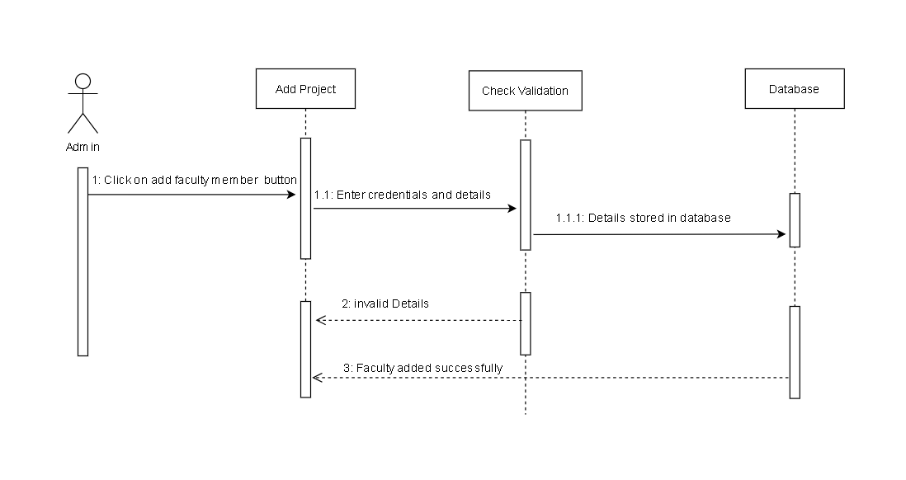

**FR17: View Grade Report**

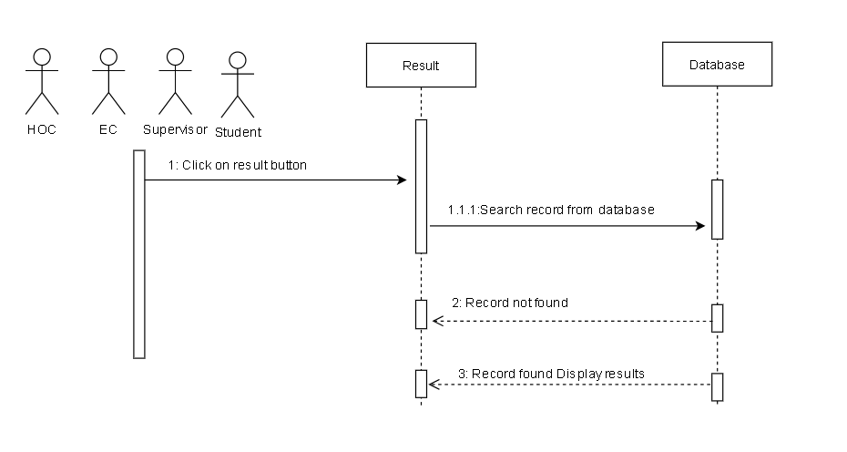

#### FR18: Set Due Dates

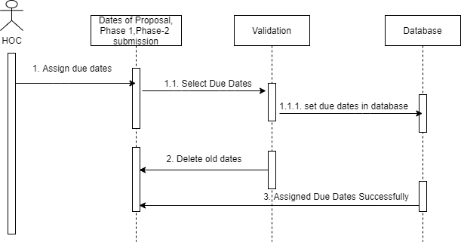

#### FR19: View Group Details

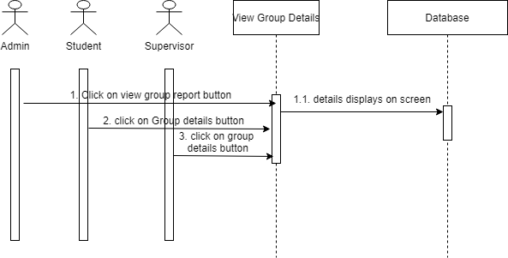

#### FR20: View Faculty Details

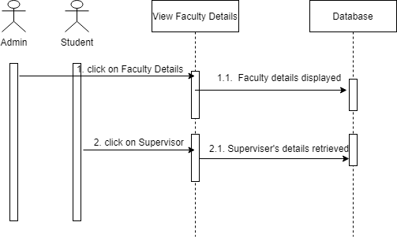

#### FR21: View EC Details

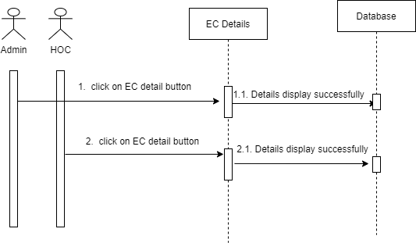

#### FR22: View Supervisor Details

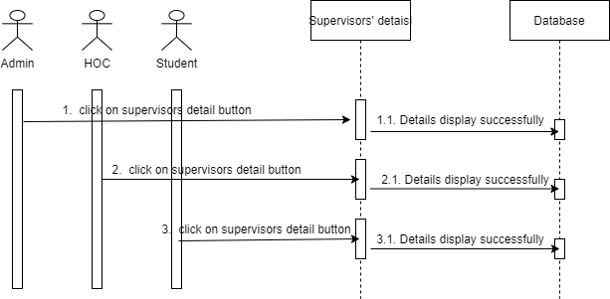

#### FR23: Upload Grade

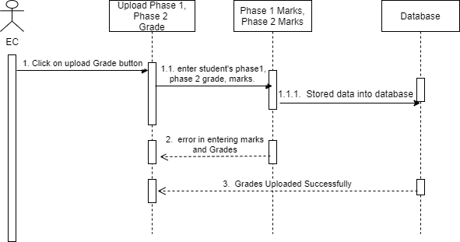

#### FR24: Notification Alert

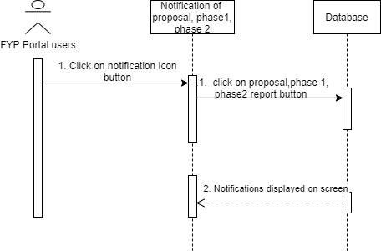

#### FR25: Logout

